**WEBAPI 02**

**Aim:**

Create a .Net core web application with API template. (Use existing application if created). Install Swashbuckle.AspNetCore Nuget package. Post this do the following steps in Startup.cs

**Program.cs:**

using Microsoft.AspNetCore.Hosting;

using Microsoft.Extensions.Hosting;

namespace SwaggerDemo

{

    public class Program

    {

        public static void Main(string[] args)

        {

            CreateHostBuilder(args).Build().Run();

        }

        public static IHostBuilder CreateHostBuilder(string[] args) =>

            Host.CreateDefaultBuilder(args)

                .ConfigureWebHostDefaults(webBuilder =>

                {

                    webBuilder.UseStartup<Startup>();

                });

    }

}

**Startup.cs:**

using Microsoft.AspNetCore.Authorization.Infrastructure;

using Microsoft.AspNetCore.Builder;

using Microsoft.AspNetCore.Hosting;

using Microsoft.Extensions.Configuration;

using Microsoft.Extensions.DependencyInjection;

using Microsoft.Extensions.Hosting;

using Microsoft.OpenApi.Models;

using System;

namespace SwaggerDemo

{

    public class Startup

    {

        public Startup(IConfiguration configuration)

        {

            Configuration = configuration;

        }

        public IConfiguration Configuration { get; }

        public void ConfigureServices(IServiceCollection services)

        {

            services.AddControllers();

            services.AddSwaggerGen(c =>

            {

                c.SwaggerDoc("v1", new OpenApiInfo

                {

                    Title = "Swagger Demo",

                    Version = "v1",

                    Description ="TBD",

                    TermsOfService = new Uri("https://example.com/terms"),

                    Contact = new OpenApiContact

                    {

                        Name = "John Doe",

                        Email = "john@xyzmail.com",

                        Url = new Uri("https://www.example.com")

                    },

                    License = new OpenApiLicense

                    {

                        Name = "License Terms",

                        Url = new Uri("https://www.example.com")

                    }

                });

            });

        }

        public void Configure(IApplicationBuilder app, IWebHostEnvironment env)

        {

            if (env.IsDevelopment())

            {

                app.UseDeveloperExceptionPage();

            }

            app.UseSwagger();

            app.UseSwaggerUI(c =>

            {

                c.SwaggerEndpoint("/swagger/v1/swagger.json", "Swagger Demo");

            });

            app.UseRouting();

            app.UseAuthorization();

            app.UseEndpoints(endpoints =>

            {

                endpoints.MapControllers();

            });

        }

    }

}

**EmployeeControllers.cs:**

using Microsoft.AspNetCore.Http;

using Microsoft.AspNetCore.Mvc;

using System.Collections.Generic;

namespace SwaggerDemo.Controllers

{

    [ApiController]

    [Route("api/[controller]")]

    public class EmployeeController : ControllerBase

    {

        private static List<string> employees = new List<string> { "John", "Alice", "Bob" };

        [HttpGet]

        [ProducesResponseType(StatusCodes.Status200OK)]

        public ActionResult<IEnumerable<string>> Get()

        {

            return Ok(employees);

        }

        [HttpPost]

        [ProducesResponseType(StatusCodes.Status201Created)]

        public ActionResult Post([FromBody] string name)

        {

            employees.Add(name);

            return Created("", name);

        }

    }

}

**Output 1:**

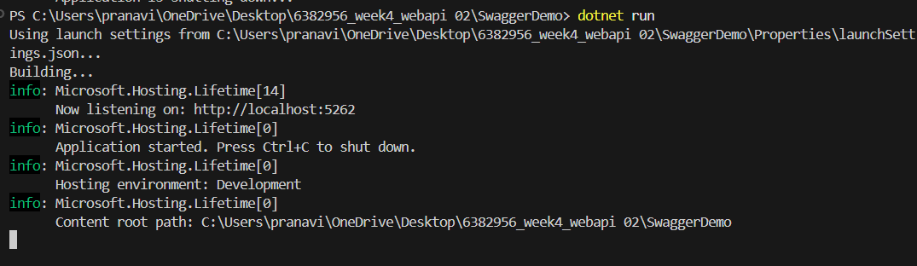

**Output 2:**

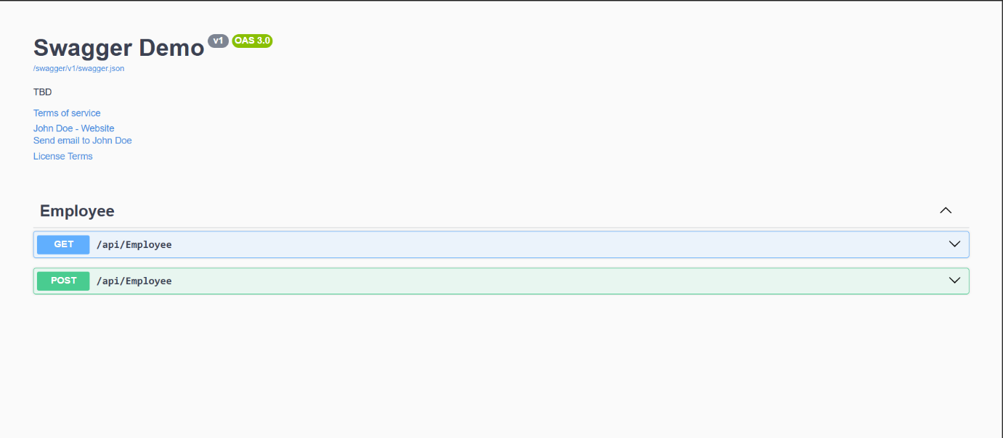

**Output 3:**

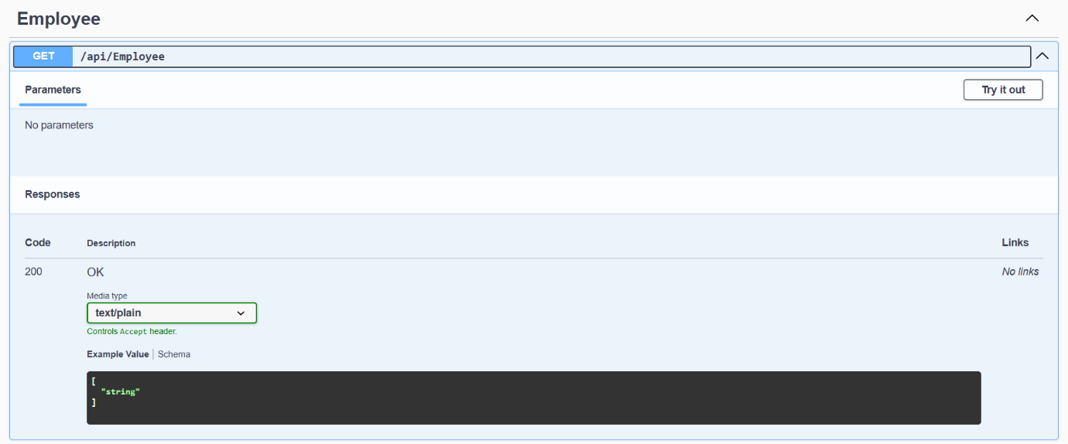

**Output 4:**

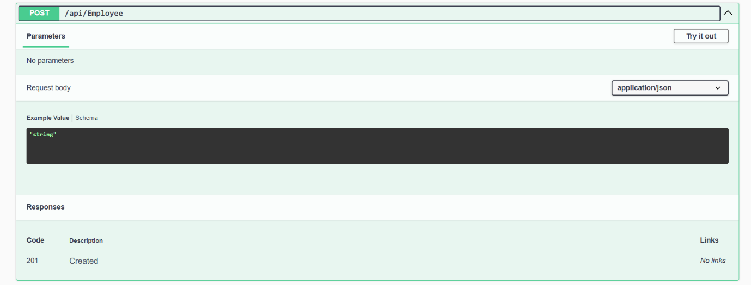

**Output 5:**

